

FortnaPlus Control
Transfer Scan Simulation
Document Revision: 1.1
Date: 21-Oct-2022

Revision | Date | Author | Revision Summary
1.0 | 25-Apr-2013 | P D Rotter | New document
1.1 | 21-Oct-2022 | T R Kremser | Update and general refresh

Table of Contents
Glossary of Terms 4
1. Document Objective 5
2. Basic Transfer Operation 5
2.1. Transfer Induction 5
2.2. Routing Request / Assignment 5
3. Transfer Configuration 5
4. Transfer Scan Simulation Configuration 6
4.1. Table Batches 6
4.2. Table XfSimConfig 6
5. Simulation Scan Options 8
5.1. Auto-Generated Scans 8
5.2. Static Scan List 9
5.2.1. Static Scan List Specifications 9
6. Transfer Simulation Control Panel 10

Confidential/Proprietary Statement
This document contains trade secrets and information that is considered confidential and proprietary to Fortna, Inc. It may not be duplicated, used, or disclosed outside the original recipient organization, and it may not be duplicated, in whole or in part, for any purpose other than to evaluate this document. Fortna Material Handling reserves the right to modify this document as necessary to reflect any terms and conditions negotiated and included as part of a subsequent contract or purchase order.

Glossary of Terms
AC – Automation Controller
CommCore – Fortna business-logic software used to determine destinations for containers and to record data on the disposition of containers processed in the warehouse. Also referred to as “Level 2”.
CRR – Container Routing Request. A message initiated by the AC to CommCore. Used to determine the disposition for a container at a scan point.
FPC – FortnaPlus Control. Fortna conveyor control software. Also referred to as “Level 1”.
UPS – Uninterruptible Power Supply

Document Objective
Describes the transfer scan simulation feature. Simulated scans can be delivered to a transfer configuration for testing purposes. Example configuration elements are given.

Basic Transfer Operation
Transfers usually refer to a particular type of hardware used to direct containers to one of two or more destinations. They handle a single container at a time at each decision point and have much lower throughput than sorters. The transfer configuration module software is really just an elaborate state machine, so it can be used for many different purposes.
The basic operation can be described as follows:
  - Transfer Induction
A container blocks a photoeye as it enters the transfer area.
A scanner reads an identifying barcode on the container.
  - Routing Request / Assignment
FPC sends a CRR message to CommCore and receives a reply specifying the container’s desired destination.
The destination is used to determine the sequence of events to direct the hardware to move the container to that destination.
Note that it is possible to configure transfers to handle containers without using a scanner and CRR message, but this document will focus only on configurations using scanners and CRR messages.

Transfer Configuration
For full details on configuring transfers, see documents: FPC-New-Transfers and FPC-Transfer-Configuration-Checklist. These documents can be found in the Redmine FortnaPlus Control project at https://redmine.fortna.com/projects/fortnaplus.
This document assumes the transfer that will receive the simulated scans has already been configured and debugged according to the instructions given in the above documents.

Transfer Scan Simulation Configuration
The scan generation module must be activated and configured.
  - Table Batches
An entry is required in table Batches (Configuration Menu | Standard Controls Batches) to activate the transfer scan simulation module:
Batches Table, part 1
File_Name | HowOften | Increment | Type | Process | InternalProc
Trans Scan Sim | 1 | INVALID | Count | CTRL

Batches Table, part 2
File_Name | InternalProcCTRL | Machine | AllMachines | DoFile
Trans Scan Sim | XfrApp Sim CTRL | <select AC name> | N | N

  - Table XfSimConfig
The XfSimConfig table (Configuration Menu | Transfer Utilities | Transfer Sim Config) defines how the simulated scans will be created.
The Transfer Simulation Configuration table (XfSimConfig)is used to define a set of containers for simulations.
NOTE: When using a configuration from a real project, use the SimCrrCsu field to create a CSU and a DCM without actually running the transfer. This provides the ability to process a CRR response and respond with a CSU and DCM without creating a simulation transfer.
Transfers may be configured in a test environment to send carton routing requests to a test CommCore instance to test the system throughput and to test the interactions between the AC and CommCore.
You will need a transfer configuration with at least XfRouteBoss, XfRouteTable, XfrBoss and XfrTree entries. The transfer should simulate a transfer event including a DCM.

XfSimConfig Table
Field | Type | Description
Name | String | Enter a unique name for this simulation configuration.
EnableXfr | Y/N | Enable or disable this entry.
Status | String | The software will use this field to show status or error information.
AppTransfer | PopUp | Choose the XfRouteBoss record associated with this simulation.
NumContXfr | Int | Set the highest container number to assign.
CurContXfr | Int | The container number for the container currently being processed by the transfer. This number must be less than NumContXfr or the simulator will not induct containers!
NumCharScan | Int | The length, in characters, of the container ID string to generate. Must be no greater than 20.
PreFixString | String | Optional static string to start each container ID. You can leave this blank if it is not needed.
PostFixString | String | Optional static string to end each container ID. You can leave this blank if it is not needed.
ScanDevice | PopUp | Choose a scan device from the ScnScanDevice table. It is used to build the CRR message.
SimTimer | PopUp | Choose a timer to control the time between scan events. Set the timer Preset_Value as needed to simulate the throughput requirements for the transfer.
SimCrrCsu | Y/N | Determine if messages will be processed by the simulator.  N = The simulation will not process any messages. Use this if you are connected to a “real” CommCore instance.  Y = The simulation will process CRR, CSU and DCM messages received from the transfer for the decision point (ScnScanZone_ScanZoneID XfRouteTable_HostRouteStr).
InductEye | PopUp | Choose the transfer induct photoeye, XfrBoss_ProductINPUT. For testing purposes, the induct photoeye can be forced on for each induction, but this will result in each container reusing the same tracking record. To better simulate real-world conditions, select the induct photoeye in this field so the simulator can turn it ON and OFF as needed.
InductCycleTimer | PopUp | Choose a timer to control InductEye. It sets the dwell time that the eye will stay on after it is triggered by the simulator.
ScanSimMenu | PopUp | Optional. Choose a table to draw the simulation container ID, scan and scale data from. Use XfrSimScans1 – XfrSimScans5.
SimScanFile | String | Optional. Define the full path to a file that contains the simulation data. The data will be loaded in to ScanSimMenu.
LoadFile | Radio | Click this to load data from SimScanFile.
WrapScanList | Radio | If checked, the simulation will re-use the scan list data in ScanSimMenu when it reaches the end of the list.
ResetSimulation | Radio | Click this to reset the simulation. The software will reset it and set pCurrSimRecord to 0.
pCurrSimRecord | Int | Set by the software to the row index of the record currently in use in table ScanSimMenu.

Simulation Scan Options
Two methods are available for creation of simulated induction scans.
  - Auto-Generated Scans
This method dynamically builds scan data as simulated containers are inducted into the transfer based on format information supplied in the following XfrSimConfig table fields:
- PreFixString – All simulated scan strings begin with the prefix supplied in this field.
- PostFixString – All simulated scan strings end with the postfix supplied in this field.
- NumCharScan – The length of the generated container ID.
The simulated container ID is generated using a sequential number, incremented for each new container, taken from the CurContXfr field.
Example:
- PreFixString = “START”
- PostFixString = “END”
- NumCharScan = 10
The first three containers inducted into the transfer would be identified as:
- “START0000000000END”
- “START0000000001END”
- “START0000000002END”
This method is useful when the content of the scan data is inconsequential or CommCore routing is being simulated by FPC.
When using this method, be sure to set these fields as follows:
- NumCharScan: A value from 0 to 20 for the sequential portion of the identifier
- PreFixString: Can be left blank
- PostFixString: Can be left blank
- ScanSimMenu: None
- SimScanFile: Leave this field blank
- InductEye: INVALID
- InductCycleTimer: N/A
  - Static Scan List
This method retrieves predefined simulation scans from an external scan list as each container is inducted. This option is useful when specific scan data must be simulated to match CommCore testing requirements. The simulation scan list is supplied by an external text file which can be dynamically selected to change simulation scan lists quickly and easily.
When using this method, the auto-generation fields (PreFixString, PostFixString and NumCharScan) are ignored.
When using this method, be sure to set these fields as follows:
- ScanSimMenu: Choose one of five simulation scan tables: XfrSimScans1 – XfrSimScans5
- SimScanFile: The path to a text file containing the list of scans
- LoadFile: Use this button to load the SimScanFile
- WrapScanList: Use this button to control whether the list is reused when the end is reached
- ResetSimulator: Use this button to reset the simulation counter
- InductEye: Choose the induct eye here so the simulator can control it
- InductCycleTimer: Choose a timer here to control the dwell time for the InductEye
    - Static Scan List Specifications
The text file selected in SimScanFile must be plain ASCII text with one scan value per line. Example:
TestScan000
TestScan001
TestScan002
TestScan003
TestScan004

Transfer Simulation Control Panel
The transfer simulation feature has a user control panel to modify settings and control the simulation. Launch it with: Configuration Menu | Transfer Utilities | Transfer Sim Scans | Xfr Sim Control Panel
It provides intuitive controls for starting, stopping, and resetting the simulation, and allows the most frequently used parameters to be adjusted without opening the XfSimConfig table.
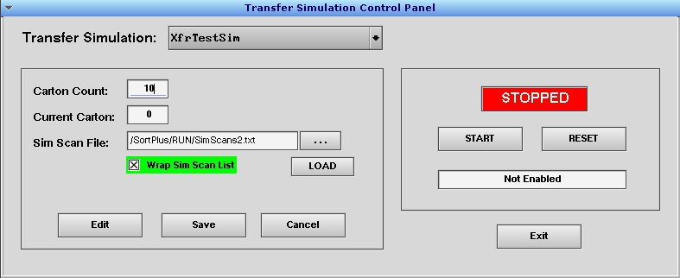
The fields on the left side of the control panel correspond to fields in the XfSimConfig table: Choose the row in the table using the “Transfer Simulation” pull-down menu at the top. “Carton Count” is NumContXfr. “Current Carton” is CurContXfr. “Sim Scan File” is SimScanFile. “Wrap Sim Scan List” is WrapScanList. “LOAD” is LoadFile.
Note that to change the “Carton Count” and “Current Carton” values, you must first click the Edit button. The affected field descriptions turn red while in edit mode. Click Save to record the changes. Any changes are available for use immediately.
Use the “…” ellipsis button to open a file selection dialog to help choose the “Sim Scan File”. Note that the default file path is /SortPlus/RUN, but you can use absolute path names if desired. Store your files within /SortPlus/RUN if you want them to be saved with the rest of the configuration! Click Open in the file selection dialog to select your file. Click LOAD in the control panel to read the file.
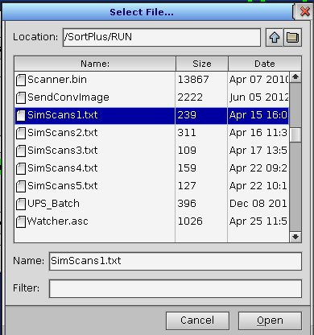
Changes to “Wrap Sim Scan List” take effect immediately – no need to click Save.
The controls on the right side of the control panel allow you to start, stop and reset the simulation. The START button will change to STOP while the simulator is running. The text box shows the current status.
The Exit button closes the Transfer Simulation Control Panel.

